1. Data understanding
2. orders

Whether there are repetitive order_id per each customer_id?

SELECT

COUNT(order_id) AS number_order,

COUNT(customer_id) AS number_customer

FROM orders;

(99441, 99441)

* count the number of orders per status

SELECT

COUNT(order_id) AS number_delivered

FROM orders

WHERE order_status = 'delivered';

(96478)

SELECT

COUNT(order_id) AS number_delivered

FROM orders

WHERE order_status = 'shipped';

(1107)

SELECT

COUNT(order_id) AS number_delivered

FROM orders

WHERE order_status = 'canceled';

(625)

SELECT

COUNT(order_id) AS number_delivered

FROM orders

WHERE order_status = 'unavailable';

(609)

SELECT

COUNT(order_id) AS number_delivered

FROM orders

WHERE order_status = 'invoiced';

(314)

What the specific order status mean:

* delivered: delivery to the customer finished
* shipped: payment finished and delivery started accordingly.
* invoiced / approved / processing: payment finished and waiting for the start of delivery
* unavailable: It might be the cancellation from the seller's side
* canceled: the canceled order would be the cancellation from the customer's side.

1. Payments

SELECT

COUNT(distinct order_id) AS distinct_orders,

COUNT(payment_sequential) AS total_payment,

COUNT(payment_sequential) - COUNT(distinct order_id) AS duplicated_rows

FROM payments;

(99440, 103886, 4446)

There are some customers pay an order with more than one payment method.

There are 5 methods for payment_type:

SELECT DISTINCT payment_type

FROM payments;

(credit_card, boleto, voucher, debit_card, not_defined)

1. Reviews

There are more than 800 duplicate rows on review_id. If review_id is same => every content except “order_id” is the same.

SELECT

COUNT(DISTINCT review_id),

COUNT(review_id)

FROM reviews;

(98410, 99224)

There are more than 500 duplicate rows on order_id in reviews table. If order_id is same => every content is different from each other.

SELECT

COUNT(DISTINCT order_id),

COUNT(order_id)

FROM reviews;

(98673, 99224)

There are null values on 'review_comment_title' and 'review_comment_message': 88.3%, 58.7% are null values respectively.

SELECT COUNT(*) AS total_rows,

(SELECT COUNT(*) FROM reviews WHERE review_comment_title IS NULL) AS total_null

FROM reviews;

(99224, 87656)

SELECT COUNT(*) AS total_rows,

(SELECT COUNT(*) FROM reviews WHERE review_comment_message IS NULL) AS total_null

FROM reviews;

(99224, 58247)

1. Products & english_product_name

There aren’t duplicate rows on product_id. Total 73 category names, 32,951 products.

SELECT COUNT(*),

COUNT(DISTINCT product_id),

COUNT(distinct product_category_name)

FROM products;

(32951, 32951, 73)

There are some products that are not in any category (NULL value at product_category_name).

SELECT product_id,

p1.product_category_name,

p2.product_category_name_english

FROM products AS p1

LEFT JOIN english_product_name AS p2

ON p1.product_category_name = p2.product_category_name;

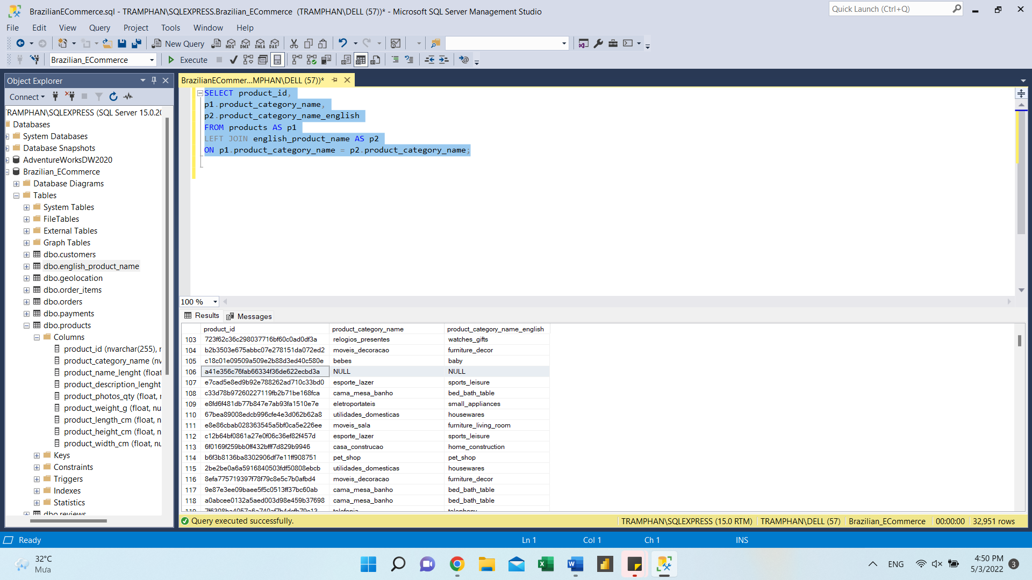

1. Sellers

There aren't duplicated rows on 'seller_id'. Total 3095 sellers.

SELECT COUNT(*),

COUNT(DISTINCT seller_id)

FROM sellers;

(3095, 3095)

1. Customers

There aren't duplicated rows on 'customer_id'. Total 99441 sellers.

SELECT COUNT(*),

COUNT(DISTINCT customer_id)

FROM customers;

(99441, 99441)

The distinct number of customers: 96096.

SELECT

COUNT(DISTINCT customer_unique_id)

FROM customers;

(96096)